Rhythm
Runner
Project Report
California State University, Northridge
COMP 467 Multimedia Systems
Fall 2017

Prepare By Team X:
Dillon Hour
Hongyou Xiong
Paul Fussell

October 09, 2017
1. Project Goals

Games that have been developed in the past have mainly focused on creating visual interactions between the players rather than audio interactions. Rhythm Runner, a 2D side scrolling runner game, will implement music and sounds that will correlate to the player's actions. Our goals are to create a fully functional game that will be completed and playable by the end of the semester. We will be using Unity as our main game developing platform which will allow us to create a 2D fully functional game. We will be designing our own web based game, that combines both audio and visual interactions between the players.

Our team has created and set deadlines to make sure that the project will be completed within the short time frame. We will make sure that the user interface and the user experience is fun and easy to use. These interfaces will include, the main menu, level selector, settings, score tracker, pause menu, and game over screen. Additionally, we will be creating different levels with different obstacles to avoid repetitive stage layouts. Consequently, each level will provide the user with a sixty second gameplay where the game is neither too long or to short. This is great for the on the go gamer who likes to play fast and quick games. Once our game is completed, we want to make it playable on Windows and Mac PCs.

2. Project Description

2.1 Project Overview

Rhythm Runner is an independent and self contained product for COMP 467 Multimedia Systems. This product is under development by a team of three members. The goal is to complete this project within a nine week time span. Developing this game will provide a great opportunity for each member to be familiarized with C#, and Unity.

Rhythm Runner is an arcade style 2D rhythm game which allows the player to take control and run through obstacles. This single player fast action paced game will be comprised of multiple levels and different stage obstacles. The user’s goal is to reach the finish line without getting destroyed and to collect as many coins as possible. Completion of a level will allow the player to unlock a new level which will grant the user the ability to continue his/her quest.

Rhythm Runner will be compatible on Windows, and Mac OS as well as working with all major web browsers such as Chrome, Firefox, Internet Explorer, and ect..

2.2 The Purpose of the Project

The purpose of this project is to create and deliver a fully functional “Rhythm” style game in a space of nine weeks. This game will include the basic features of the player scores, a level selector, different rhythms, and different obstacles. This product intended to run off Windows and Mac operating systems only. This document will help outline the goals, tools, and information needed for development.

2.3 Project Scope

Rhythm Runner is a side scroller rhythm running style game. The purpose of this game is combine musical beats, and sound frequencies with the player actions. Each player will have a one minute experience on each level with 6 different levels to complete. The player's objective is to run across a platform and dodge different obstacles while collecting coins. The more coins the player collects, gives them a better chance to get the high score.

Each week will be comprised of a different task and goal for the project, in which the team needs to complete. Therefore, by scheduling different task each week, it will allow the team to release a fully functional game by the deadline of nine weeks. The team will be using the Unity platform to create the game and will be programming with C#. Additionally, the API provided by the Unity application will be used.

3. Project Breakdown

3.1 Tools

Game Creator - Unity, Visual Studios, and Photoshop.
Communication - GitHub, Discord, Gmail, Google Drive, and Skype.

We’ve chosen to use Unity for this project as the game engine of choice. To write C#, we’re going to use Visual Studio 2017 as an IDE and Photoshop for basic 2d sprite manipulation. To communicate and maintain work, we’re going to utilize Github for source control and Skype / Discord for communications. Documentation will exist and be shared across Google Docs, so that we can collaborate on work.

We looked at a bunch of options for the game engine: Ogre, GameMaker, Unity, and Unreal Engine. Ogre is an open-source game engine that does provide a lot of useful features. The language it supports is C++, but it does not provide any physics or audio capabilities. That makes it unusable for the project even though it is the main open source option. We could import an audio library but it would introduce more risk into the project.

GameMaker is a 2D visual programming IDE to generate 2-dimensional games. It is considerably slower to run than C++ or C# because it is a scripting language engine. In addition, it is hard to write the algorithms necessary to adjust and manipulate the audio because it is all visual scripting. GameMaker is also a proprietary license that you can try for free but is not free to use. This makes it more difficult to choose as an engine.

Unity and Unreal stood out as the two enticing choices; both provide deep tutorial libraries and also a wealth of features. Unity uses a mixture of C# and visual scripting while Unreal uses C++ and Blueprint, their own version of visual scripting. They both support audio manipulation through an API and are typically used in industry setting. Both have lots of support online and are constantly being worked on, and are free for users to use as long as the projects are below a certain profit line. We opted to use Unity because our team has used it before and tends to be easier to use for simpler 2d games than Unreal.

We pretty much unilaterally chose to use Visual Studio for our choice of IDE because of how many features is built into it. It comes with a compiler for various languages including C#, and also a debugger that bare-bones IDEs do not provide. There are also GitHub integration plugins in the Visual Studio package library, which helps to reduce the friction between source control.

Communications are going to be over Skype, Discord and text message. This allows us to work even though we are all scattered about and communicate in real time with one another. Files that we collaborate on will be housed on Github for code and Google Drive for other documents. Google drive is convenient for collaborative sharing and editing of files. The other options included Dropbox and Microsoft One, but there were no competitive advantages to use one or the other and we’ve used Google Drive primarily in the past, so we chose to use that instead of others. Github is more convenient for sharing private repositories, especially for students. It is easy to integrate with Visual Studio and serves its job well for code files. While Git is not great for binary assets, it will be sufficient as the scope of the project itself limits the amount of assets needed in the system.

3.3 Scheduling

Week 1: Learn how to use Unity, C#, and set up all communication applications.
Week 2: Player movement, camera angle, and creating platforms.
Week 3: Player health, speed, and coin creation.
Week 4: Player score, creating obstacles, and restart on death ability.
Week 5: Player user interfaces such as the main menu, game over screen, pause menu, high scoring system, and level selector.
Week 6: Adding sound effects, and game animations.
Week 7: Implementing all the features together.
Week 8: Game testing and debugging.
Week 9: Game ready for release.

4. User Specifications

4.1 Functional Requirements

4.1.1 User Interface

Rhythm Runner will be supported on the web and will also be downloadable for any player who wants to play directly off their computers instead. We will ensure that the user interface will easy and simple to use. Once the player starts Rhythm Runner, he will prompted to the main menu where he/she will have the options to; start a new game, continue, go to settings, or quit the game. If the player has not played before, he/she will click on “new game”, which will start the player to the first level. When a player clicks “continue”, he/she will be about start back from where he/she left off. If the player clicks on “settings”, he/she will be able to adjust the volume, access the player manual, and clear the data. Lastly, if the player wants to quit the game, he/she will have the option to quit in the main menu.

As the user is playing the game, there will be a couple of user interfaces that will be included, such as the pause menu, or game over screen. When the game is paused, the user will be able to go back to main menu, quit the game, or restart the level. If the player gets killed during the level, he/she will have the option to restart the level, or go back to main menu.

4.1.2 Hardware Interface

The user must have a fully functional computer with the Mac or Windows operating system, as well as have internet access. Our game will be web-based, so the player needs to be able to access the web to play the game. Additionally, the user must have a keyboard or mouse to be able to control the player's movement in the game. Optional hardware may include speakers that will allow the user to hear the sounds and music within the game.

4.1.3 Software Interface

We will build our game using Unity’s WebGL’s build option which will allow the us to make it playable through the web. WebGL is a Web Graphics Library built on the JavaScript API used to render interactive objects that include both 3D and 2D graphics on compatible web browsers such as Mozilla Firefox or Google Chrome. This makes it so the user does not require any plug ins for the browser because it makes use of the HTML5 elements and OpenGL ES 2.0. By using an existing and proven library for the basis of the game we can ensure that time is spent more on gameplay development and that Rhythm Runner has the reliability that gamers today demand.The web browsers that we intended to build it on are Google Chrome, Firefox, and Safari.

4.1.4 Communication Interfaces

There will be no communications interfaces since this will not be a multiplayer, or online game that will allow player to player interaction. All data from the game will be save locally onto the user's computer.

4.2 Non-Functional Requirements

4.2.1 Performance Requirements

The game should run at least 30 frames per second and use at most 512 MB of RAM. Dedicated graphics card should not be required to play such as those high end graphics cards such as NVIDIA, or AMD Radeon graphics. This game will be playable with any sound card capable of stereo output.

4.2.2 Usability Requirements

Novice and inexperienced game players should be able to play our game. There should be little to no learning curve for all players. The game should have straight forward gameplay and basic/intuitive mechanics. Once the player starts gameplay, it will be as simple as to duck and jump.

4.2.3 Security Requirements

There will be no security requirements since the game will be played through the web or will be locally saved onto the user's workstation. The only thing that can be stolen is the game data, but no personal information will even be required from the user.

4.2.4 Maintenance Requirements

Assets of each team member should be separated so that everyone’s contribution may be maintained separately. Additionally, unused assets will be deleted in order to keep the memory of the game low and efficient. Therefore, by delete these unused asset, it will create a faster and more optimized game. Future patches will only address game-breaking bugs after release. Beyond that, the team will be continuously test the games for any further bugs and will take action upon each bug that is encountered.

4.2.5 Extensibility Requirements

When the semester is finished, we plan on extending the game by creating more levels and releasing new characters. Therefore, we will be expanding the gameplay by adding new player objectives and goals. However, we will still implement the same gameplay style of having the players actions correlate with the sounds in the game.

4.3 Wireframes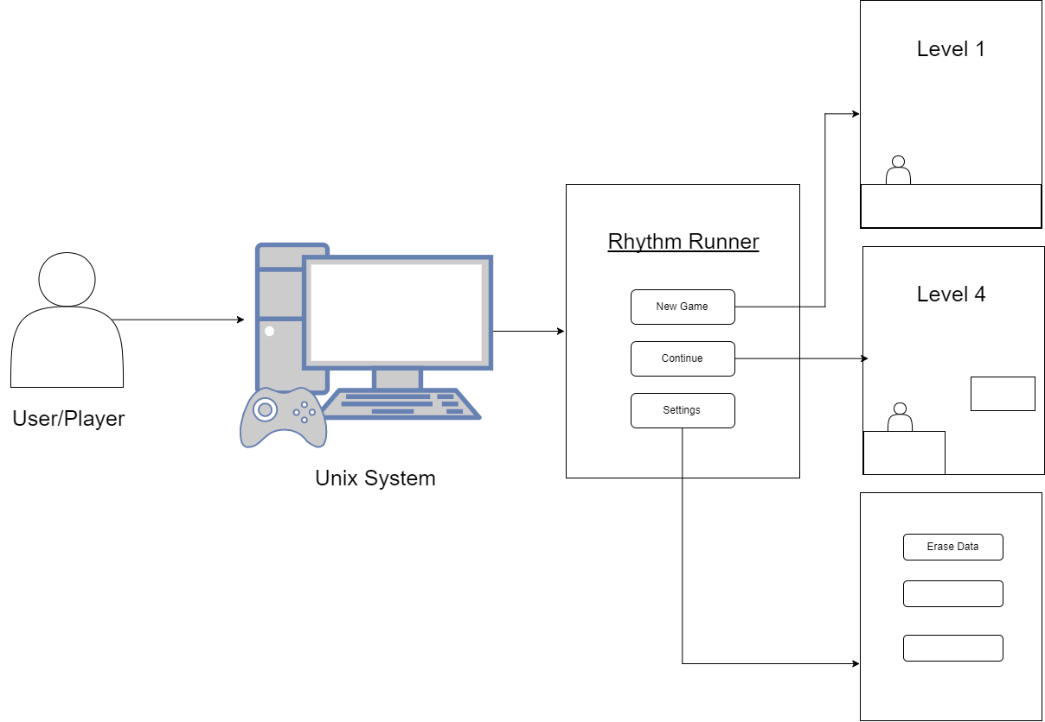

5. Architecture

- Class Diagram -
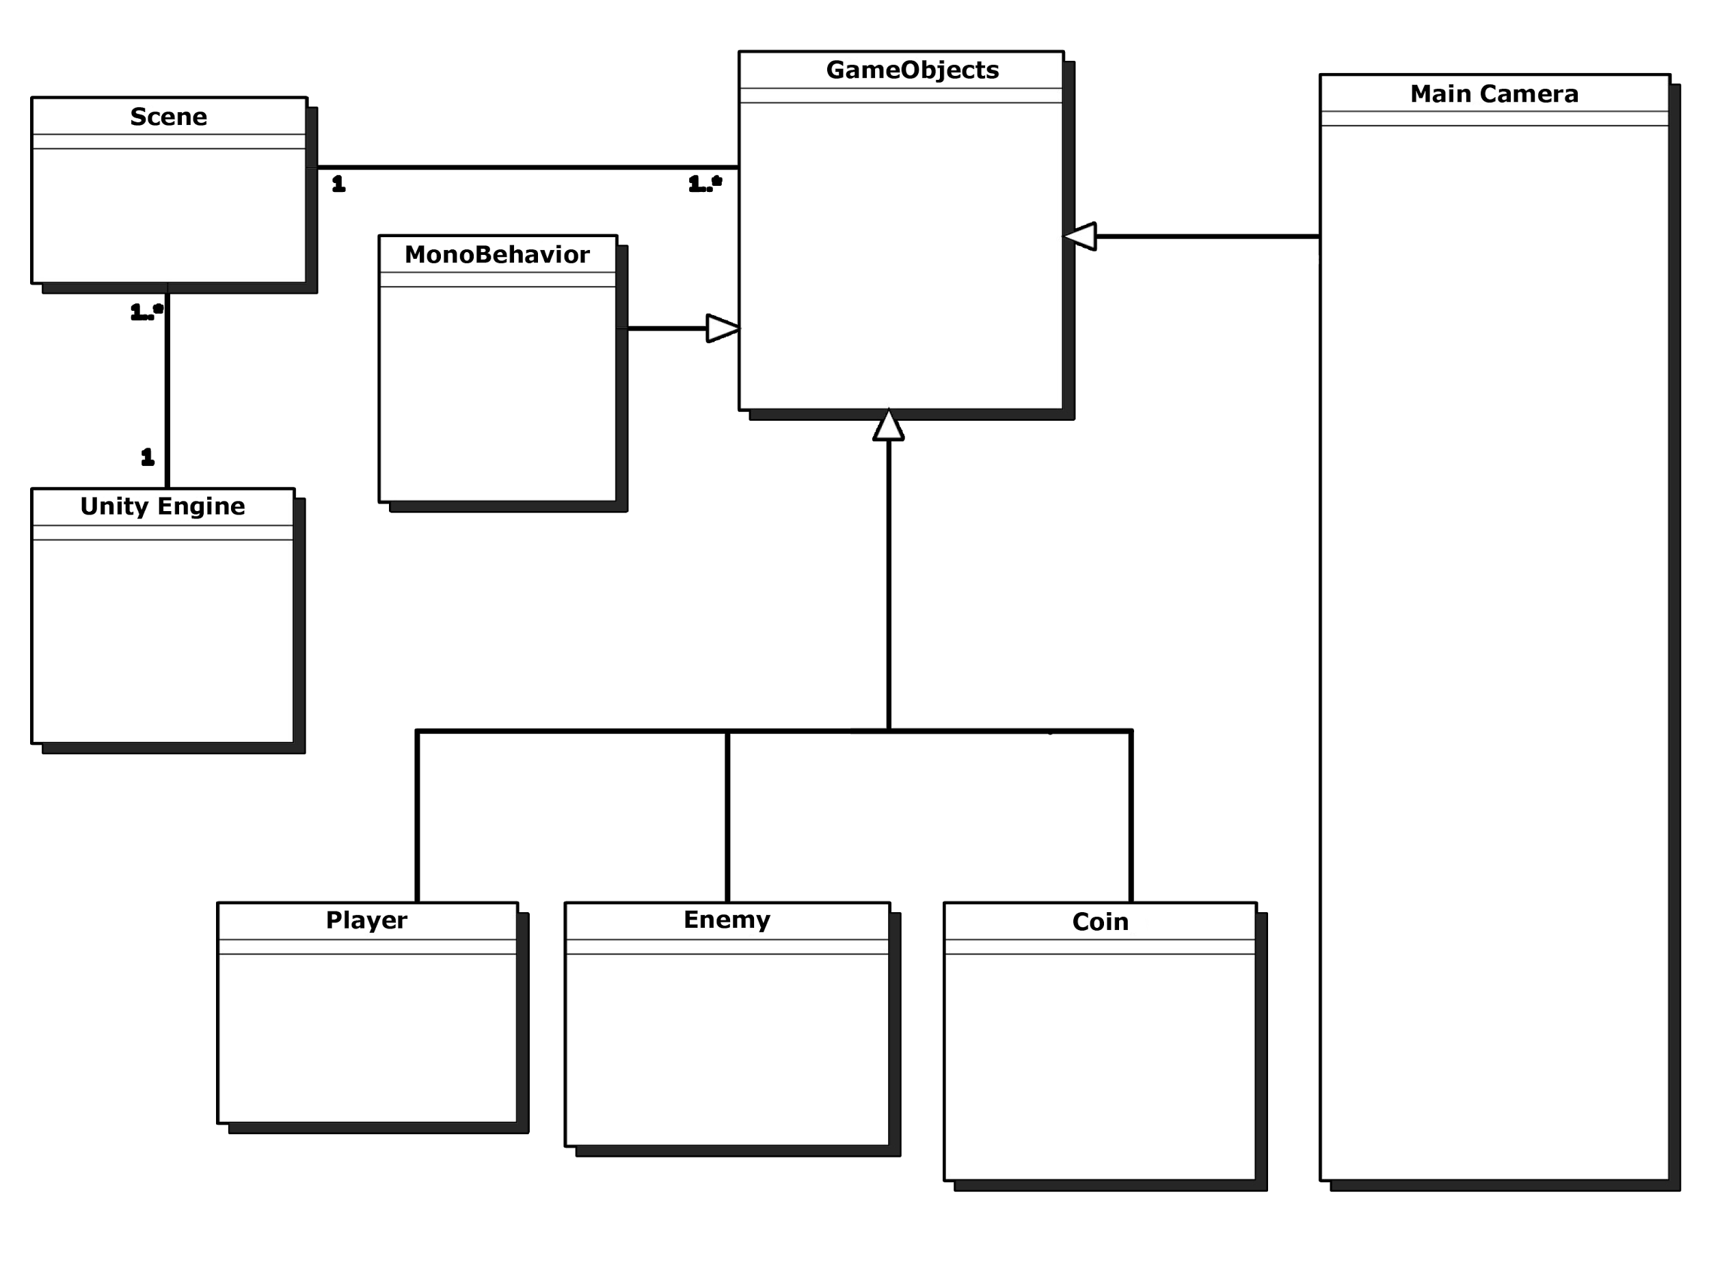
- Package Diagram -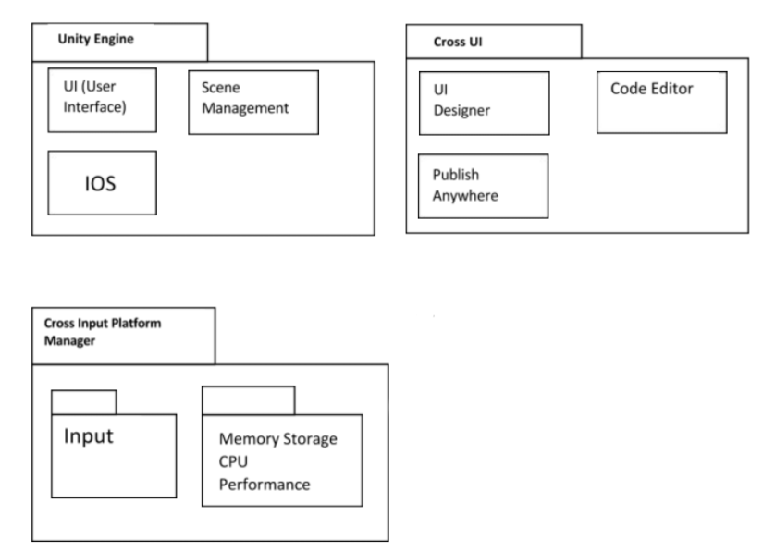

- Object Diagram -

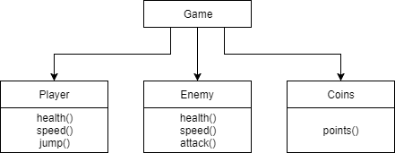

- Component Diagram -
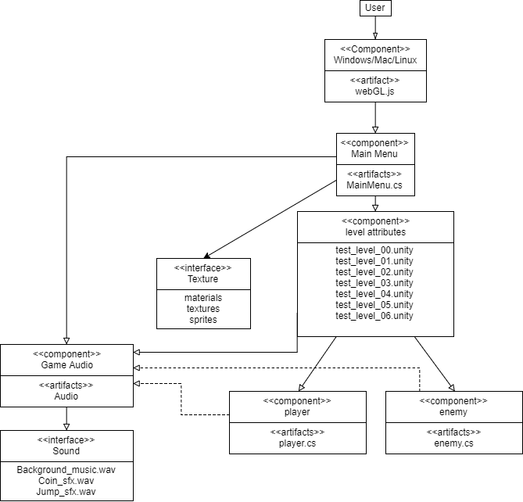

- Deployment Diagram -
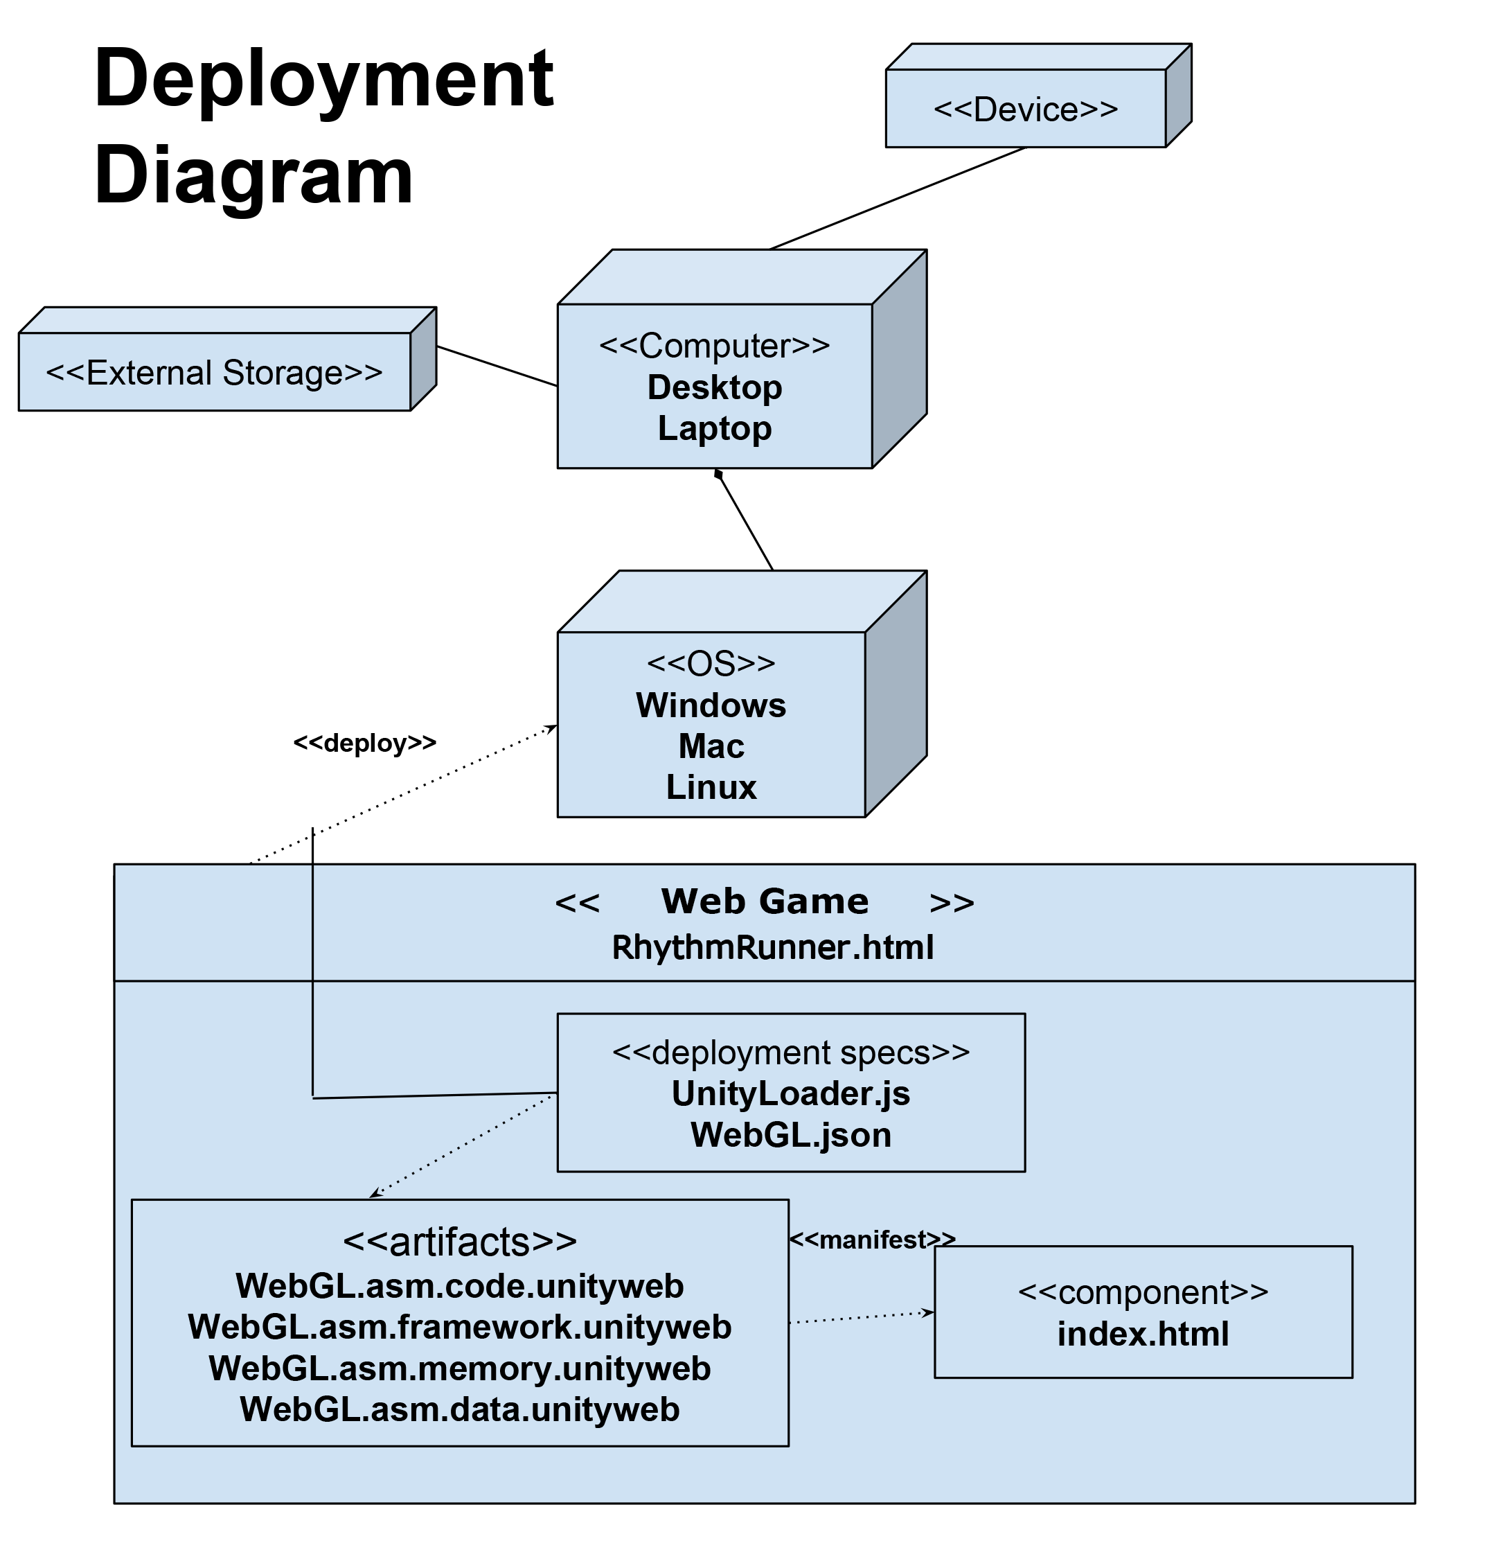

- Activity Diagram - 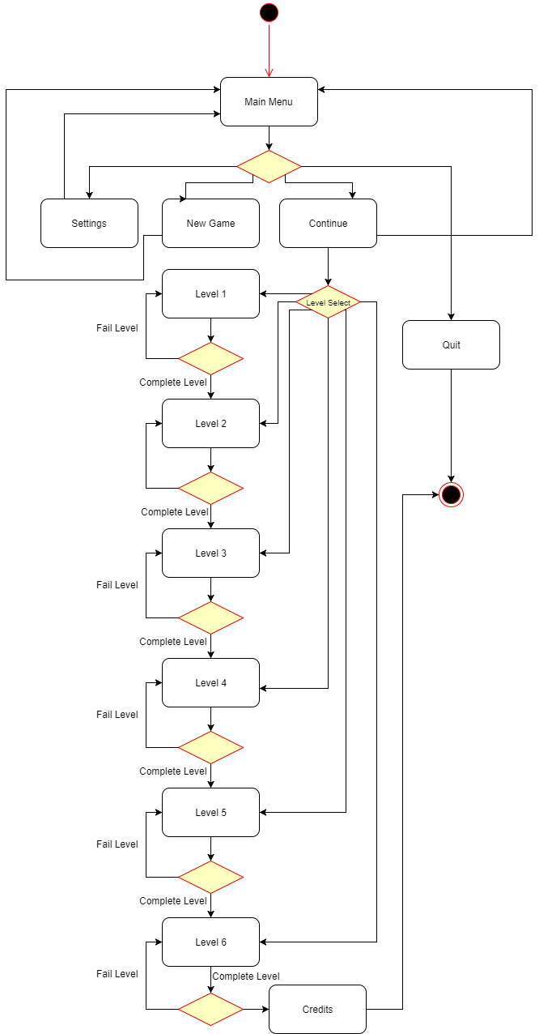

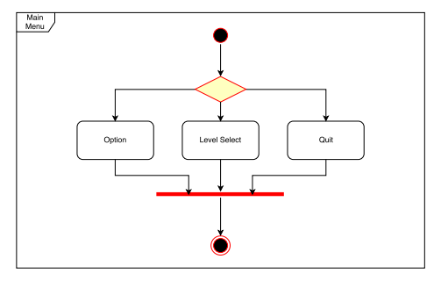
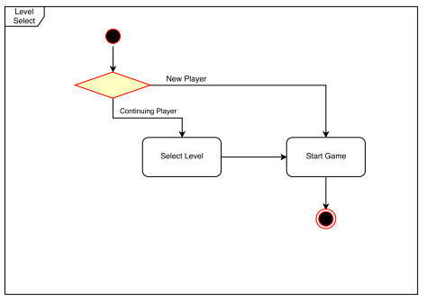
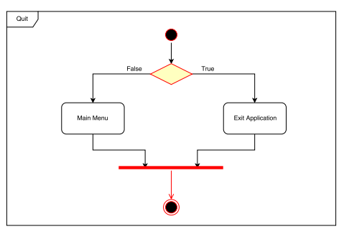
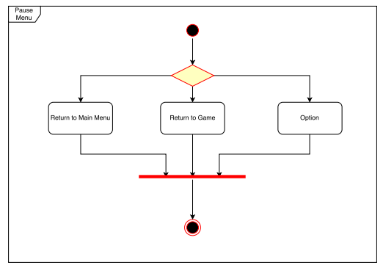
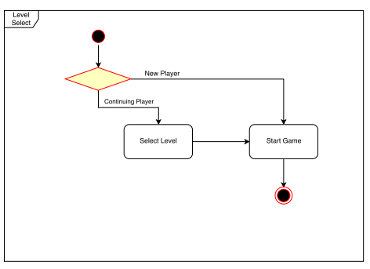

- Sequence Diagram -
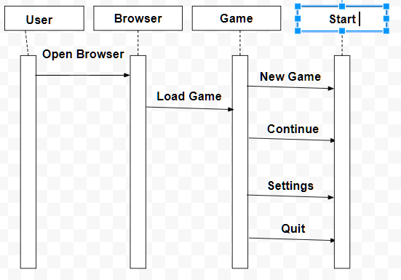

- Use Case Diagram -
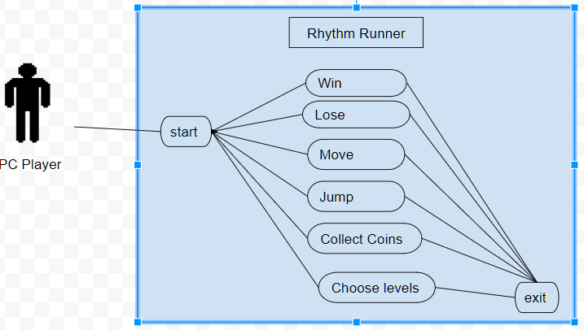

- State Diagram -
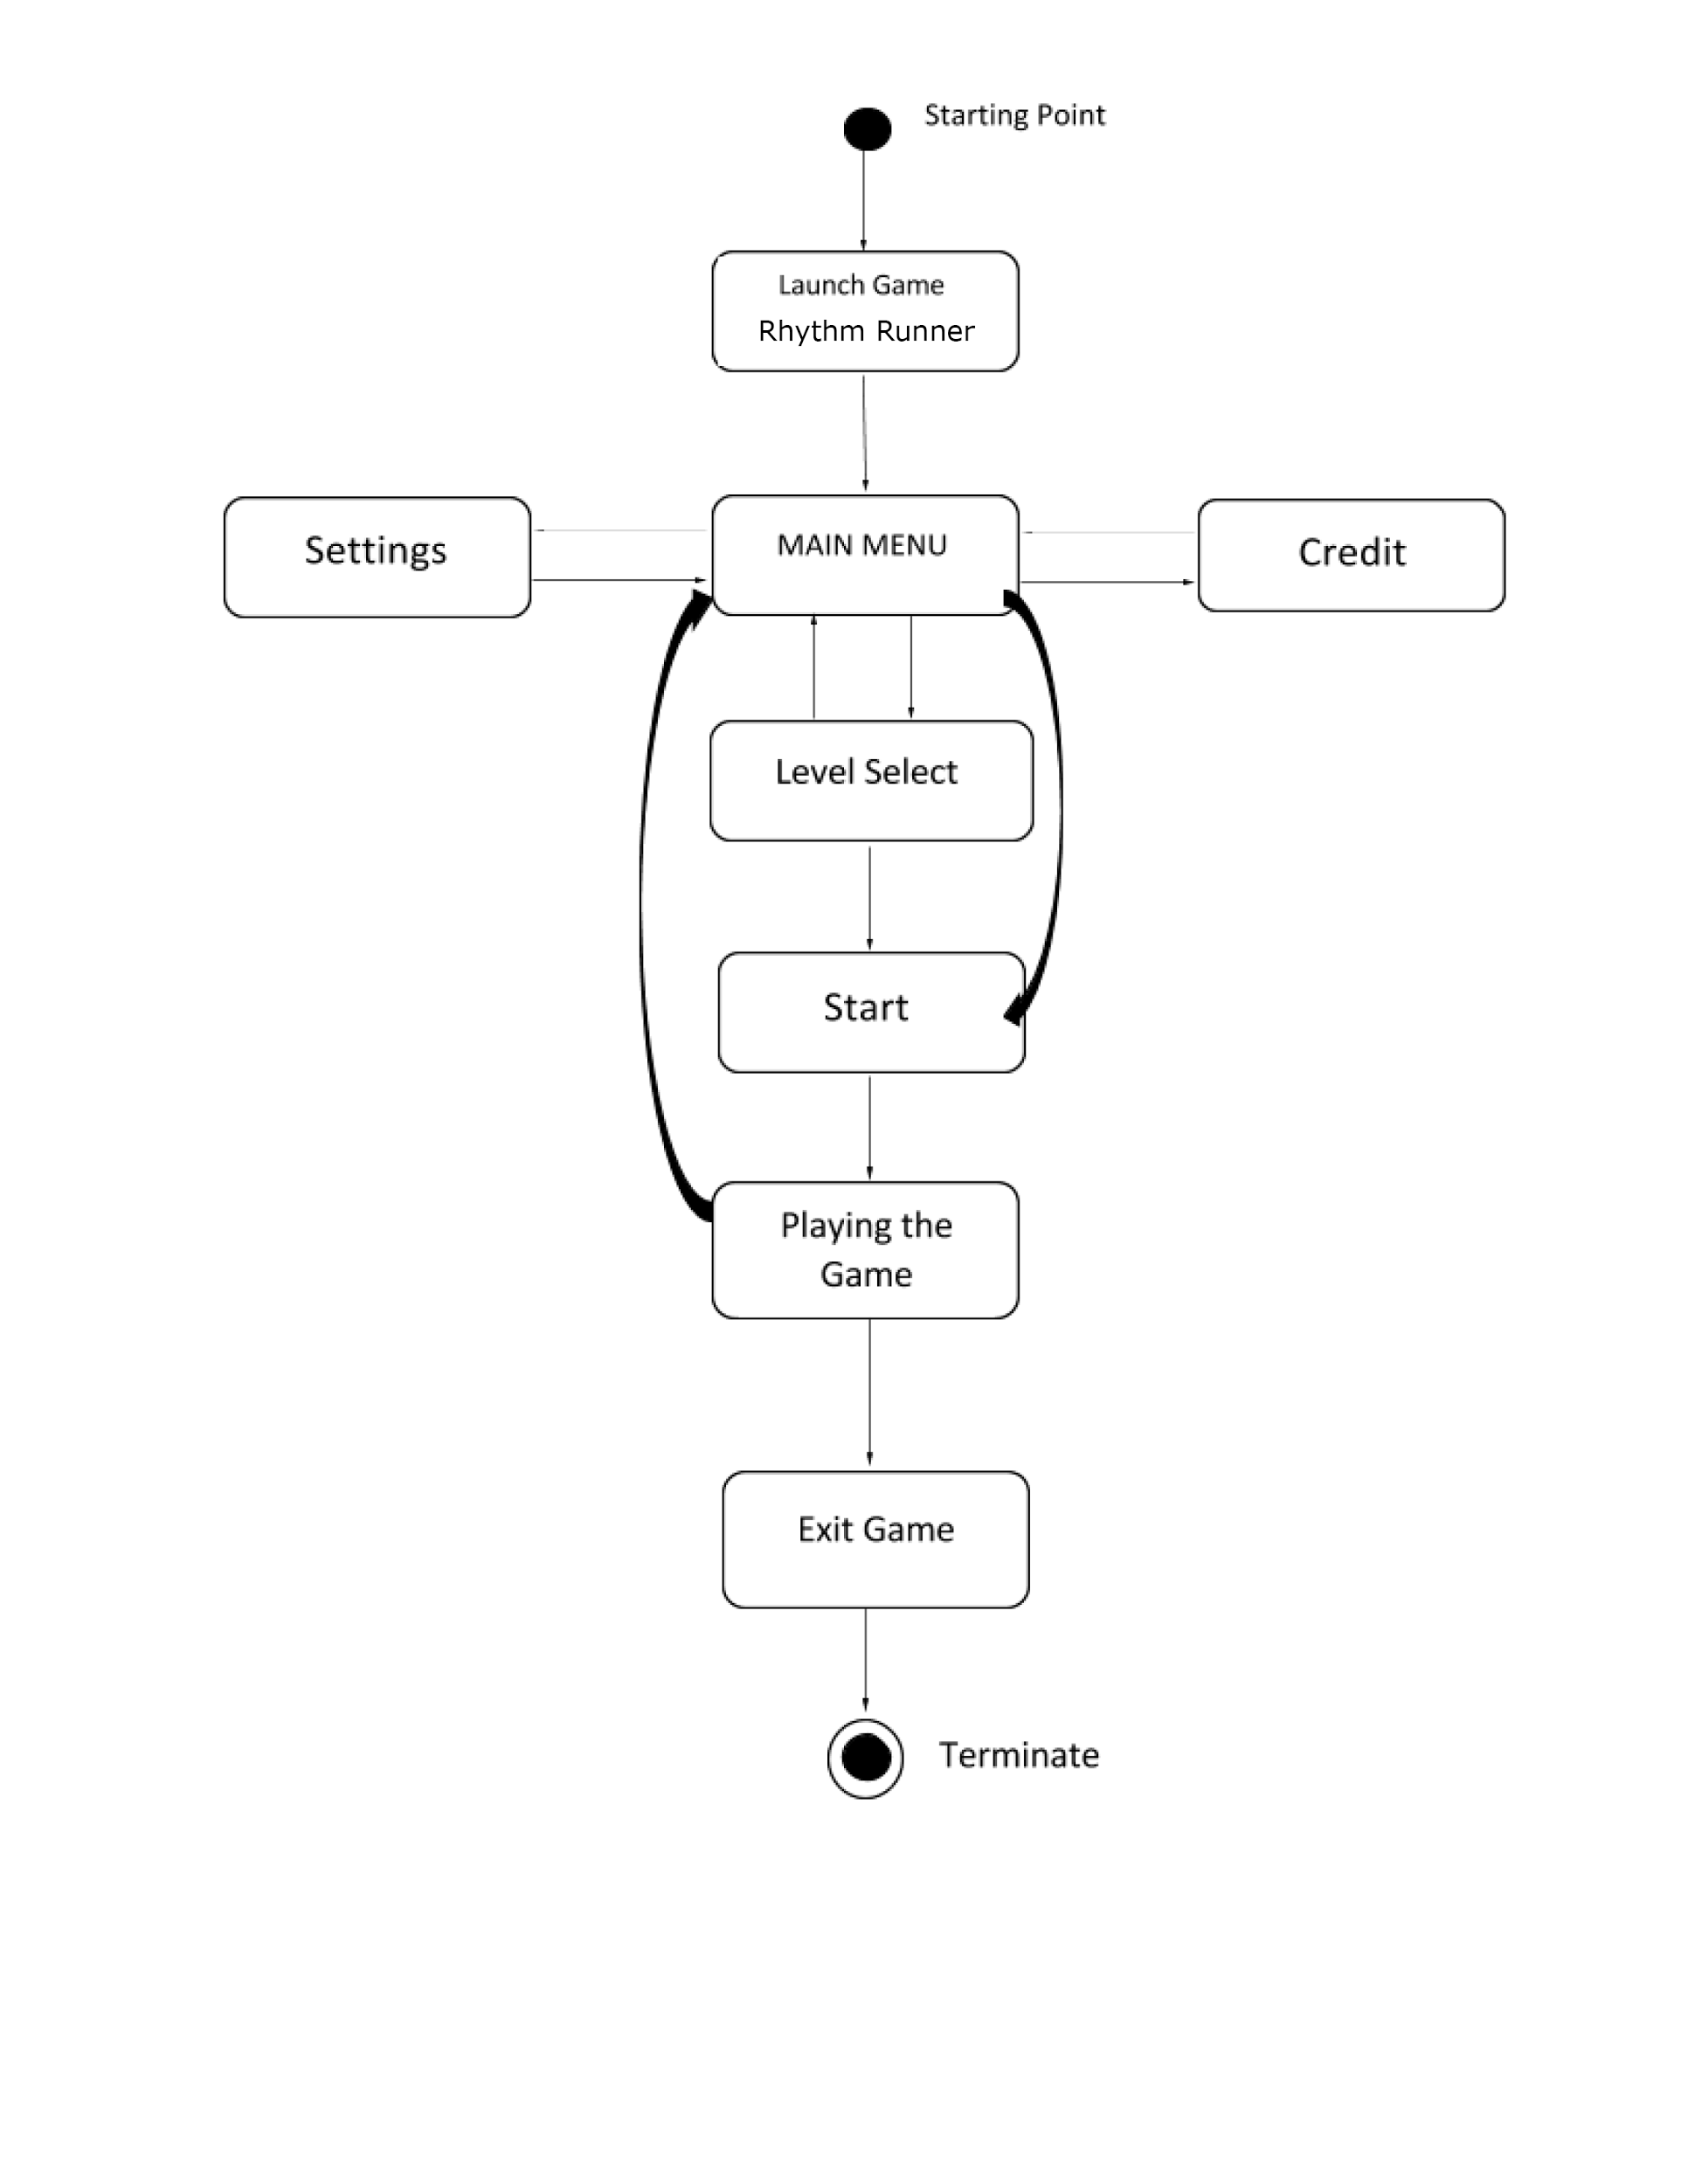

- Interactions Overview Design - 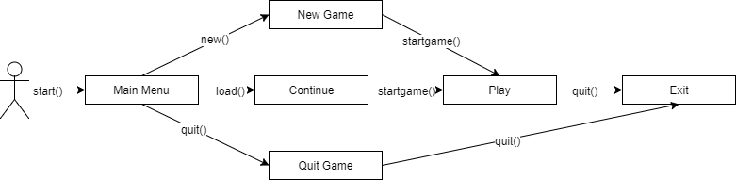

6. Code Guidelines

6.1 Naming Conventions

6.1.1 Class Name Conventions

Class names will be determined and named according to the functions of the script. For example, if the script deal with the movement of the player, then we will name the class PlayerController or if the the script deals with the player’s health, then we will name it PlayersHealth. Therefore, our classes will be named according to what they do in the game.

6.1.2 Variable Name Conventions

Variable names will be lowercase, short, and accurately describe the values that are stored within them, as well as their purpose. For example, we will have a function that regulates the players movements and we will call name the variable speed. Speed will allow us to change how fast the player moves and runs.

6.1.3 Function Name Conventions

Functions will be named according to it specific actions towards the game, such as start(), or update(). Start() will be code that needs to run when the game starts and Update() will run continuously until the game ends. There will be more functions that will be called upon, but refer to our architecture to see the list of functions we will be using.

6.1.4 Asset Name Conventions

The asset will be named accordingly depending on the character type, music, or to what they are related to. There will be only one character and it will be named “Player”. Objects will be named to what they are assigned to do or be, such as “ground”. Ground will be an asset that the user can use to create the floor layout of the game. The reason for naming the object this way, is to ensure the developer understands what they are used for.

6.2 Paradigms

We will be using a mixture of a bunch of simple paradigms. The core game will be a state machine, where each phase of the game is a different state. Breaking the game into Start Screen, Settings, Game, Paused, Game Over, and Quit will help make the game much more modular and each state can manage its own data.

The objects and character will be objects each housing components that are responsible for rendering, audio, I/O, and others. Component based objects mean that the object is composed using various components that allow for modular behavior. This will help us be able to work in parallel (For example, one person working on the input for the character and another person working on the animation or rendering will be able to work in parallel because they touch the character itself minimally.

The game itself runs in a loop, using events to signal I/O which will be processed in an update frame. These events are passed into the respective components mentioned above and processed by each. Some components may not care about the event; for example, an obstacle may not care that it received a keyboard input. Each component will process each event independently and update the state. This state is then reflected in the next frame of the game.

6.3 Patterns

We will be employing various design patterns to help make the game easier to create and more performant. Unity provides an implementation of object pools, which is used so that we do not create and destroy all objects, but rather reuse the objects with slightly altered parameters. This will be used together with factories to generate random obstacles based on the audio being processed.

The standard design pattern for Unity games is to use components heavily. Components as mentioned in the Paradigms section allows heavy modularity and parallelization while working on the same object. This is because any object is just a list of components that it includes and minimally handles passing events it receives to each component that cares about the event. This helps reduce the amount of stepping on each other’s toes while working as well as help reuse objects (Obstacle object may have a location component that is responsible for its position, and that would be the only thing that needs to change between many different obstacle objects).

We are considering making the game state itself a singleton because that means that the source of truth can remain in one object that is used across all objects in the game. This helps to reduce passing around the game state itself and bloating the function signatures of all game functions.

6.4 Frameworks

We will be using all of Unity’s built in frameworks and APIs, which include their own C# scripting languages and we will be using Unity’s collaboration features. The collaboration feature allows developers to interact with other developers which allows them to share code and work on the same project.

6.5 Error Handling

If we encounter an errors in our code, we will use Visual Studio's to run it which will then tell us what is wrong with the code. Additionally, we will be using Unity’s documentations to fix any errors with the code. Unity provides full documentations on how to use certain functions and give tutorials on how to use it. To ensure that our games has no bugs during gameplay, we will be constantly testing it to catch any errors that may occur during gameplay. If there are any errors that occur, we will immediately fix it by reviewing our code and making the right changes for it.

6.6 Logging/Testing

Once we have completed our project, we will be testing all of our code using visual studios. Visual Studios will help us check for any errors in our code. Additionally Unity, has an application called “console” where it logs all of the errors that are affecting the gameplay. Therefore, we can refer to these errors and fixed them immediately. Additionally, we will perform multiple test on our game to make sure it is bug free. In other words, we will try to break/crash or own game so that we can find errors that may occur during gameplay.

6.7 Security Guidelines

There are no security guidelines as there are no security requirements. We are not implementing any user account information. Therefore, we will not have a need for security for our application. However, we will be using the built in Unity Collab feature to ensure that our code and development progress is saved on onto the cloud.

6.8 Constraints

6.8.1 Users

The user must have full internet access so that they can play the game since it will be web based. If the user does not have internet, then he/she cannot play the game since it will be on a website. Additionally, to prevent any lags during gameplay, it is suggested that the user has a computer that was built between 2014 - present.

6.8.2 Hardware

For hardware, the game requires at least 512 mb of ram, a monitor, a keyboard or mouse, 1 gb of free space and an integrated graphics card. Without these hardwares, user may be limited or may not be able to play the game.

6.8.3 Software

The game is constrained to run on unix only systems and only mainstream browsers. In other words, the software can only run on Windows, Mac, and Linux operating systems and in Chrome, Firefox and Safari browsers.

6.9 Usability Guidelines

6.9.1 Menu Organization

We will create the main menu really basic and easy to use. The main menu will consist of new game, continue, level select, and settings. Each function will navigate the player to another screen. New game will start the player onto a new adventure. Continue will have the player start off where he/she left off last. Level select will let the user replay the level he/she already defeated. Settings will allow the user to adjust different options they way he/she prefers.

6.9.2 Buttons Used

With the keyboard, the player’s directional movements will be comprise of of a couple of basic keys. These keys include, w (up), a (left), s (down), d (right), and the arrow keys; up, down, left, right. Additionally, to jump, the player can either hit the spacebar, or click the left click button on the mouse.

6.10 Links

- https://unity3d.com/
- https://github.com/
- https://www.google.com/drive/
- https://discordapp.com/

